**Practice Questions for Robot Mechanisms – GIM**

**Velocity and acceleration analysis of Planar Mechanisms using GIM**

**Software link:** <https://www.ehu.eus/compmech/software/>

1. Draw the planar mechanism in GIM and compare with the analytical method

[A]

[B] 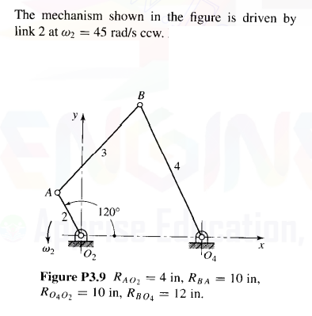

The offset slider-crank mechanism shown in figures 1 and 2 is driven by a motor with angular velocity ω2 = 500 rpm (ccw) at A. Determine the instantaneous velocity of point E and the angular velocities of the links in the mechanism. AB link angle is 45 degree.

